SYSTEM ANALYSIS

Final Project

UHI

2021

 **Universal Health Insurance **

***Project Members***:

* ***Safa Anwar Arafa***
* ***Ghidaa Mohamed Mohamed***
* ***Mayada Magdy Abdelbary***
* ***Noura Mahmoud Monuir***
* ***Nada Reda Afifi***
* ***Yousef Ahmed Ahmed***

***Supervision***

**Dr. Khaled Mohamed Foaad**

**Eng.Rowida Adel**



BFCAI 3rd year student

Contents:

Section 1. Project Overview 3

1.1 Project Description 3

1.2 Project Scope 3

1.3 Assumptions 2

1.4 Constraints 3

Section 2. Project Start-Up 4

2.1 Project Life Cycle 4

2.2 Methods, Tools, and Techniques 4

2.3 Estimation Methods and Estimates 5

2.4 Schedule Allocation 5

2.5 Resource Allocation 6

2.6 Budget Allocation 7

2.7 Scheduling Project Plans 8

Section 3. Risk Management 11

Section 4. SSR 12

Section 5. SOW 13

Section 6. Baseline Project Plan Report 15

Section 7. Walkthrough Review Form 19

Section 8. Modeling 20

8.1 Process Modeling 20

8.2 Data Modeling 24

Section 9. Design 26

Section 10. Implementation and Operation ……………………………...64

10.1 coding………………………………………………………..64

10.2 testing………………………………………………………...64

10.3 operation……………………………………………………...64

Section 11.Feature work …………………………………………………64

conclusion………………………………………………………………...65

Section 1. Project Overview

* 1. ***Project Description***

What is universal health insurance?

It is a mandatory social solidarity system that covers all citizens, and the state guarantees those who are unable. As it separates funding from the provision of health services, and the flexibility of the service package provided, which is not less than the services currently provided. It provides high-quality health services, and 30% of the population is classified as "unable" and will be covered by the state. The comprehensive social insurance to be applied covers all groups of society as a whole, meaning that the whole society will be subject to its insurance umbrella in return for payment of contributions. Within it the unit of coverage is the family and not the individual, as in the current system. Provides access to and support for the insured's freedom to choose between any of the health service providers, whether in the governmental or non-governmental sectors, included in the comprehensive health insurance network. It is subject to a uniform law that avoids the defects of existing laws. It applies to the fields of insurance health services and does not apply to public and preventive health services or health services for covering natural disasters, epidemics and similar services that all state agencies are bound by. Through it, the mechanism for pricing medical services is determined in a fair manner that meets the quality standard, through a committee represented by the private, public and independent sectors. The percentage of citizens ’participation in the current law ranges between 1% of the employee's insurance wage, and 3% of the employer per month, and in the new law it will be the same, but on the total income, in addition to the family head paying the contributions of the person responsible for them, namely: the non-working wife At a rate of 2.5%, and the rest of the family at a rate of 0.75% for each person, and the state treasury pays the contribution of those who are unable. The subscriber to the new health insurance pays a nominal percentage, at the time of performing the x-rays, up to 10% and 20% for analyzes, to control the provision of the service, while the surgeries are performed without any contributions except for the payment of the basic subscription.

***1.2*** ***Project Scope***

*Our project serves all segments of society, whether able or not, by providing all medical services that:*

*1. Contributions include the family as a whole, not just the individual.*

*2. The subscribers provide health care, which includes checks and examinations, some surgeries and other high-quality analyzes and rays, in addition to the percentage of discounts on them.*

*3. It allows the subscriber to choose a hospital that is close to him or of high quality and that belongs to that system at reduced costs.*

*4. It provides patients with chronic diseases monthly medicines and dispensing medicines free of charge*

*5. Keep patient data confidential.*

*6. Motivates the most efficient doctors to increase their salaries.*

*7. It did not include governmental and insurance hospitals only, but also hospitals affiliated with higher education and private hospitals.*

*8. Provide every citizen with his own medical record, which is served in an organized periodical way.*

*9. Provide a database that includes patients' data and the latest updates on it on a regular basis, which can be accessed through any hospital affiliated with the system.*

|  |
| --- |
| **Project Includes** |
| Citizens' participation in universal health insurance. |
| Every patient has its medical record and every family has its family doctor. |
| The treatment is free of charge, and there are discounts on surgeries and examinations. |

|  |
| --- |
| **Project Excludes** |
| The imposition of a government hospital and the lack of eligibility to choose the appropriate hospital for treatment. |
| Employee participation and non-tolerance for all segments of society. |

***1.3*** ***Assumptions***

*The project includes assumptions that:*

*The head of the family goes to the comprehensive health insurance unit and gives the administrator all the data about the family to make medical record for the family with a unique number, and all family members make a comprehensive examination*

*that includes a ‘primary examination, analysis and radiation’ and add the medical history of all family member, then add of all that to the family medical record, pay contributions, and assign The family doctor for each family and he is responsible for the therapeutic trip for that family and adding the data to the family file, and when the visit continues at any time, the subscriber must give the administrator the number of the medical record to administrator and choose the department that he wants to examine him and make an examination then takes Treatment, and adding that visit to the family file. The patient can choose the appropriate hospital for him to do surgery or other tests.*

|  |
| --- |
| **Assumptions** |
| Save medical history of patient. |
| Treatment of the unable is at the expense of the state. |
| Increase doctors' salary. |
| Provide medicines for chronic diseases all time. |

***1.4*** ***Constraints***

|  |
| --- |
| **Constraints** |
| We must finish 25% of the project work within 2 weeks. |
| We must work within available resources. |
| Distribution of team must be effort.. |
| Provides all citizens in Egypt Arabic Republic. |
| Budget must = 50,000$.  Schedule must take 2 weeks. |
| System must be rapid. |
| Time of one task must be convenient to its size. |

Section 2. Project Start-Up

***2.1 Project Life Cycle***

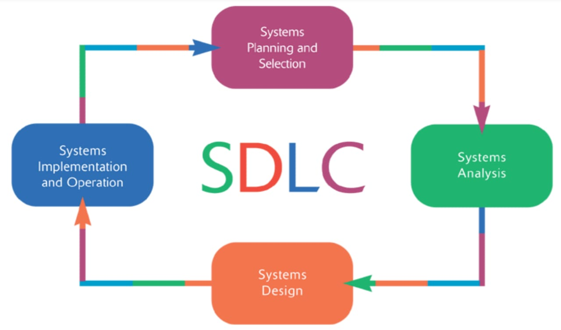

***2.2 Methods, Tools, and Techniques***

We use some technology and programming language to make this project like:

- Use database by using Visual Studio 2019.

- Html and Css by using Visual Studio 2019.

- Website by using Visual Studio 2019.

- Gant Chart Microsoft office management project.

- Creately SoftDiagram.

- We use software engineering to plan the project

***2.3 Estimation Methods and Estimates***

| **Estimation Methods and Estimates** | |
| --- | --- |
| Description | Most - likely - best - worst |
| Effort in person-months or person-hours | Hours |
| Schedule in calendar weeks | Weeks (1) …….planning  Weeks(2)… ….....collection requirements  weeks( 3)….Analysis  weeks(4)….Design  weeks(5)….Develop  weeks(6)….Maintenance and testing  weeks(7)……Deliver and install  ` |
| Budget in dollars | 50,000$ |
| Level of Uncertainty | 9 % |

***2.4 Schedule Allocation***

|  |  |
| --- | --- |
| **Major Milestone/Deliverable** | **Planned Completion Date** |
| Planning | *8/11/2020* |
| Collection requirements | *16/11/2020* |
| Analysis | *24/11/2020* |
| Design | *2/12/2020* |
| Implement | *10/12/2020* |
| Maintenance | *18/12/2020* |
| Deliver and install | *24/12/2020* |

***2.5 Resource Allocation***

|  |  |  |  |
| --- | --- | --- | --- |
| **Resource** | **Total** | **Skill Set Requirements** | **Timeframe** |
| Analysis | 4 | Communication Skills. Technical Skills. Analytical Skills. Decision-Making Skills. | ………………… |
| Design | 3 | The skills required in design good user interface programming. | …………………. |
| Implementation | 4 | Good at Java and solve problems in it. | …………………… |
| Tester | 4 | know different testing techniques and usage of tools | …………………. |
| Computers | 4 | …………………………. | …………………. |
| Server | 1 | Technical Understanding, Telecommunications Technologies. | ………………… |
| Bar code system | 2 | ……………………………. | ………………….. |

***2.6*** ***Budget Allocation***

|  |  |  |
| --- | --- | --- |
| **Key Budget Category** | **Budget Amount** | **Time Period** |
| Recourses | 18000$ | ----- |
| Developer | 48000$ | 1 week |
| Database administrator database oracle | 45000$ | 1 week |
| Designer | 5000$ | 1 week |
| Analyst | 17000$ | 1 week |

**Project Budget:**

One –time cost = 75000 $  
Benefit per year = 85000 $  
Cost per year = 35000 $  
Discount rate = 12%

**#net present value of Benefit**

|  |  |  |  |
| --- | --- | --- | --- |
| Years | Y1 | Y2 | Y3 |
| Benefits | 85,000 | 85,000 | 85,000 |
| rate | 0,893 | 0,797 | 0,712 |
| Present value | 75,893 | 67,761 | 60,501 |
| Net present value | 75,893 | 143,654 | 204,155 |

**#net present value of cost**

|  |  |  |  |  |
| --- | --- | --- | --- | --- |
| Years | Y0 | Y1 | Y2 | Y3 |
| Benefits | 75,000 | 35,000 | 35,000 | 35,000 |
| Rate | - | 0,893 | 0,797 | 0,712 |
| Present value | 75,000 | 31,250 | 27,902 | 24,912 |
| Net present value | 75,000 | 106,250 | 134,152 | 159,064 |

ROI= (204,155-159,064)/159,064=0.28%

# Break even analysis

|  |  |  |  |  |
| --- | --- | --- | --- | --- |
| Years | Y0 | Y1 | Y2 | Y3 |
| Yearly npv | -75,000 | 44,643 | 39,859 | 35,589 |
| Overall npv | -75,000 | -30,357 | 9,502 | 45,091 |

Break even occurs between y1 and y2

Break even fraction= (39,859-9,502)/39,859=0, 76

|  |  |  |  |
| --- | --- | --- | --- |
| **Risk Description** | **Probability** | **Impact** | **Strategy** |
| ***Cost Estimates*** | **low** | **high** |  |
| ***Time Estimates*** | **high** | **high** | **We divided the work on all the members of the project and work together and discuss ideas together so that we deliver on time.** |
| ***Team Size*** | **low** | **low** | **In the case of the project, the number of project personnel was appropriate and if there was a shortage of an individual, the remainder would compensate for this shortage and work together.** |
| ***Team Members Unknowledgeable of Business*** | **high** | **Very high** | **We cooperated and assisted each other so that all of team knew about the project and we did research to solve any problem we face and search for the information required in this project.** |
| ***Narrow Knowledge Level of Users*** | **low** | **high** | **We have trained the user on how to use the system and deal with it.** |

Section 4. SSR

**System Service Request**

**RequestED BY: Governmental Institution DATE: 9 - 11 - 2020**   
**DEPARTMENT: Service System LOCATION: Egypt**

**CONTECT:**

|  |  |
| --- | --- |
| **TYPE OF REQUEST**  [√] New System  [ ] System Enhancement  [ ] System Error Correction | **URGENCY**  [ ] Immediate: Operations are impaired or Opportunity lost  [√] Problems exist: but can be worked around  [ ] Business losses: can be tolerated until new system installed |

**PROBLEM STATMENT**

Insurance includes categories of employees in the state sector and does not include the rest of society. Citizen’s failure to defend any operation, X-rays, or basic reconstruction analyses belonging to a country or affiliated with the health insurance system despite the poor services provided. The low salaries of doctors, which makes them tend to work in private hospitals, which makes there is a deficiency of the medical staff and a decrease in the performance of the medical work provided. The lack of a database for patients and the use of paper registration. The absence of what includes the patient’s medical history and new examinations, and therefore the absence of what includes patient data permanently when moving from one hospital to another. Failure to support rare (unavailable) medicines for people with chronic diseases who are unable to. Lack of communication with various government institutions.

**SERVICE REQUEST**

A unified law that avoids the defects of the current laws. Ensuring financial sustainability and insurance services. It applies public and preventive health services to public health services and health services that cover natural disasters and epidemics. Determining the mechanism for pricing medical services in a fair manner that achieves the quality standard through a representative of private and public relations and representatives and independents. The percentage of citizens' participation in the current law ranges between 1% of the employee's insurance wage, and 3% of the employer per month, and in the new law it will be the same percentage, but on the total income, in addition to the family head paying the contributions of the person responsible for them, which are: the nonworking wife at a rate 2.5%, and the rest of the family members at a rate of 0.75% for each person, and the state treasury pays the contribution of those who are unable. - The subscriber to the new health insurance pays a nominal “contributions” rate, at the time of the x-rays, up to 10% and 20% for the analysis, for the work of “control” in providing the service, while the surgeries are carried out without any contributions other than paying the basic subscription.

|  |
| --- |
| **IS LIAISON: ________________________________________________ SPONSOR: Benha University …………………………..TO BE COMPELETED BY SYSTEMS PRIORITY BOARD……………………...** [ ] Request approved **Assigned to: Start date:** [ ] Recommend Revision [ ] Suggest user development [ ] Reject for reason |

Section 5. SOW

Project name: Universal Health Insurance

Project manager: Ghidaa Mohamed

Customer: patient

Project start\end (projected): 1\11\2020 - 24\12\2020

**Project Description:**

***Goal***

Providing high quality health services and 30% of the people are classified as "unable" and will be covered by the state. The unit of coverage is the family and not the individual, as in the current system.

***Objectives***

1. Contributions include the family as a whole, not just the individual.
2. The subscribers provide health care, which includes checks and examinations, some surgeries and other high-quality analyzes and rays, in addition to the percentage of discounts on them.
3. It allows the subscriber to choose a hospital that is close to him or of high quality and that belongs to that system at reduced costs.
4. It provides patients with chronic diseases monthly medicines and dispensing medicines free of charge
5. Keep patient data confidential.
6. Motivates the most efficient doctors to increase their salaries.
7. It did not include governmental and insurance hospitals only, but also hospitals affiliated with higher education and private hospitals.
8. Provide every citizen with his own medical record, which is served in an organized periodical way.
9. Provides a database that includes patients' data and the latest updates on it on a regular basis, which can be accessed through any hospital affiliated with the system

***Phases of work***

The following tasks and deliverables reflect the current understanding of project:

* 1. In Systems planning and selection:
     + Project plan short.
     + System service request.
     + Scope.
     + Project charter.
     + Network diagram.
     + Statement of work.
     + Gant chart.
     + Walkthrough Review Form.
     + Baseline.
     + Economic visibility study.
  2. In analysis.
     + Data model.
     + Process model.
     + Interviews.
  3. In design:
* database design.
* human design.
  1. In implementation:
     + Code.
     + Documentation.

Section 6. Baseline Project Plan Report

|  |
| --- |
| **BASELINE PROJECT PLAN REPORT** |
| 1. **Introduction** 2. ***Project Overview***:   Universal health insurance is a mandatory social solidarity system that covers all citizens, and the state guarantees those who are unable. It provides high-quality health services. Within it the unit of coverage is the family and not the individual, it allows freedom to choose between any of the health service providers, whether in the governmental or non-governmental sectors. the mechanism for pricing medical services is determined in a fair manner that meets the quality standard.  ***B- Recommendation :***   1. *Creating SSR.* 2. *Determine Project Scope.* 3. *Divide Process into tasks.* |
| 1. **System Description** 2. **Alternatives :**  * It includes employees who follow government and outside it. * Include family as a whole, not just individual. * Allow subscriber to choose hospital. * Provides patients with chronic diseases monthly medicines. * Keep patient data confidential. * Each family has its own family doctor. * Motivates doctors to work to increase their salaries. * Include governmental hospital and private hospital. * Assign medical record to each patient. * Provide data base that includes all patients data.   **B- System Description :**  It is a mandatory social solidarity system that covers all citizens, and the state guarantees those who are unable. As it separates funding from the provision of health services, and the flexibility of the service package provided, which is not less than the services currently provided. It provides high-quality health services, and 30% of the population is classified as "unable" and will be covered by the state. The comprehensive social insurance to be applied covers all groups of society as a whole, meaning that the whole society will be subject to its insurance umbrella in return for payment of contributions. Within it the unit of coverage is the family and not the individual, as in the current system. Provides access to and support for the insured's freedom to choose between any of the health service providers, whether in the governmental or non-governmental sectors, included in the comprehensive health insurance network. It is subject to a uniform law that avoids the defects of existing laws. It applies to the fields of insurance health services and does not apply to public and preventive health services or health services for covering natural disasters, epidemics and similar services that all state agencies are bound by. Through it, the mechanism for pricing medical services is determined in a fair manner that meets the quality standard, through a committee represented by the private, public and independent sectors. The percentage of citizens ’participation in the current law ranges between 1% of the employee's insurance wage, and 3% of the employer per month, and in the new law it will be the same, but on the total income, in addition to the family head paying the contributions of the person responsible for them, namely: the non-working wife At a rate of 2.5%, and the rest of the family at a rate of 0.75% for each person, and the state treasury pays the contribution of those who are unable. The subscriber to the new health insurance pays a nominal percentage, at the time of performing the x-rays, up to 10% and 20% for analyzes, to control the provision of the service, while the surgeries are performed without any contributions except for the payment of the basic subscription. |
| **3.0 Feasibility Assessment**  **A- Economic Analysis:**   * In this system the gain is earned through paid subscription from subscribers. And contributions of employees.  1. **Technical Analysis :**  * project size don’t act a risk in our project because the number of our team are suitable  1. **Operational Analysis:**  * The head of the family goes to the comprehensive health insurance unit and gives the administrator all the data about the family to make medical record for the family with a unique number, and all family members make a comprehensive examination that includes a ‘primary examination, analysis and radiation’ and add the medical history of all family member, then add of all that to the family medical record, pay contributions, and assign The family doctor for each family and he is responsible for the therapeutic trip for that family and adding the data to the family file, and when the visit continues at any time, the subscriber must give the administrator the number of the medical record to administrator and choose the department that he wants to examine him and make an examination then takes Treatment, and adding that visit to the family file. The patient can choose the appropriate hospital for him to do surgery or other tests.   **D-Political Analysis :**   * **Update**   The work of updating the system through the addition of new medical records of patients or updating them and so on from the basic rules in the system, which must be constantly followed to know if family is recorded or not.   * **Terminate**   Remove the medical record of families that no longer pay subscriptions, calculate lack and expired medicines that taken.  **E- Schedules, Timeline, and Resource Analysis :** |
| 1. **Management Issues**   **A-Team Configuration and Management :**  -Developer : Safa Anwar.  -Designer : Youssef Ahmed, Noura Mahmoud, Nada Reda.  -System Analyst : Safa Anwar, Ghidaa Mohamed, Mayada Magdy.  **B-Communication Plan :**   * Minutes and Meetings. * Project Workbook. * Document. * Chats.   **C-Project Standards and Procedures :**   * **1-**register family data. * **2-**make comprehensive check for all members. * **3-**make medical record. * **4**-take medical record number. * **5-**pay subscriptions. * **6**-assign a family doctor to each family. * **7**-in the second visit. * **8**-choose appropriate hospital for each patient. * **9-**choose department that he want to examine in it. * **10-**doing examination. * **11-**do ordered analysis and scans. * **12**-take medicine. * **13**-record visit to medical record. * **14**-family father pays monthly subscriptions. * **15-**people with chronic diseases will take monthly treatment.  1. **Other Project-Specific Topics :**   After the agreement on the idea of the project, the team went to the comprehensive health insurance to collect the requirements and shows how the administrator add patients to system database, We went to the other side and went to the health insurance and knew how much here the beneficiary is actually the family (members), the Egyptian health ministry and doctors then did the idea of the project change to some extent. |

Section 7. Walkthrough Review Form

|  |
| --- |
| **Walkthrough Review Form** |
| Session Coordinator: Safa Anwar. |
| Project/segment: Universal Health Insurance. |
| Coordinator’s Cheek list:   1. Conformation with producer(s) that materials ready and stable: yes. 2. Issue invitation, assign responsibilities, distribute materials: [ * ]Y, [ ]N. 3. Set date, time, location for meeting:   Date: 17 / 11 / 2020 Time 09:00 AM Location: Ministry of Health at Al Qasr Al Ainy.   |  |  |  |  | | --- | --- | --- | --- | | Responsibilities | Participants | Can attend | Received material | | Coordinator | Safa Anwar | [ * ]Y [ ]N | [ * ]Y [ ]N | | Presenter | Ghidaa Mohamed | [ * ]Y [ ]N | [ * ]Y [ ]N | | User | People | [ * ]Y [ ]N | [ * ]Y [ ]N | | Secretary | Yousef Ahmed | [ * ]Y [ ]N | [ * ]Y [ ]N | | Standards | Noura Mahmoud | [ * ]Y [ ]N | [ * ]Y [ ]N | | Maintenance | Mayada Magdy, Nada Reda | [ *]Y [ ]N | [ * ]Y [ ]N | |
| Agenda:  Yes 1-All participants agree to follow PVF’s rules of walkthrough  Yes 2-New Material: Walkthrough of all material  Yes 3-Old Material: Item-by-item cheek off of previous action list  Yes 4-Creation of new Action list (contribution by each participant)  Yes 5-Group decision  Yes 6-Deliver copy of this form to the project control manager. |
| Group Decision:  Yes accept product as is.  --------- Revise (no further walkthrough).  ---------Review and Schedule walkthrough   |  |  |  | | --- | --- | --- | | Signatures |  |  | | Coordinator | Safa Anwar. |  | |

Section 8. Modeling

* 1. ***Process Modeling***

***Context***

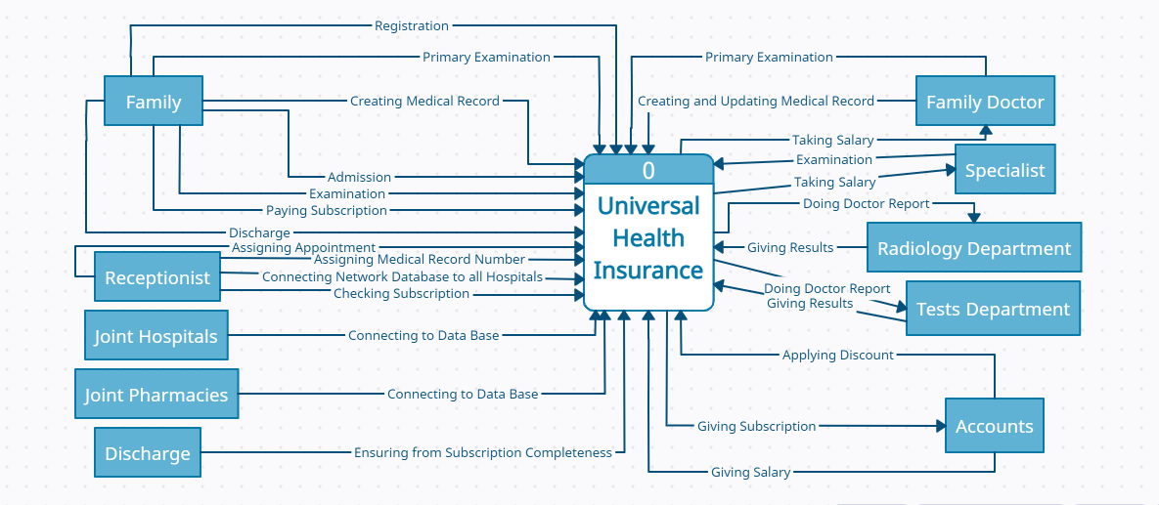

**- Data Flow Diagram**

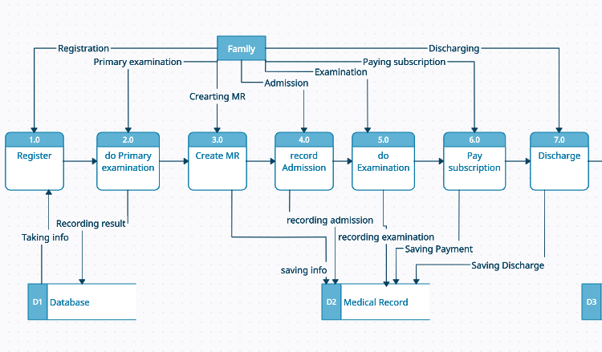

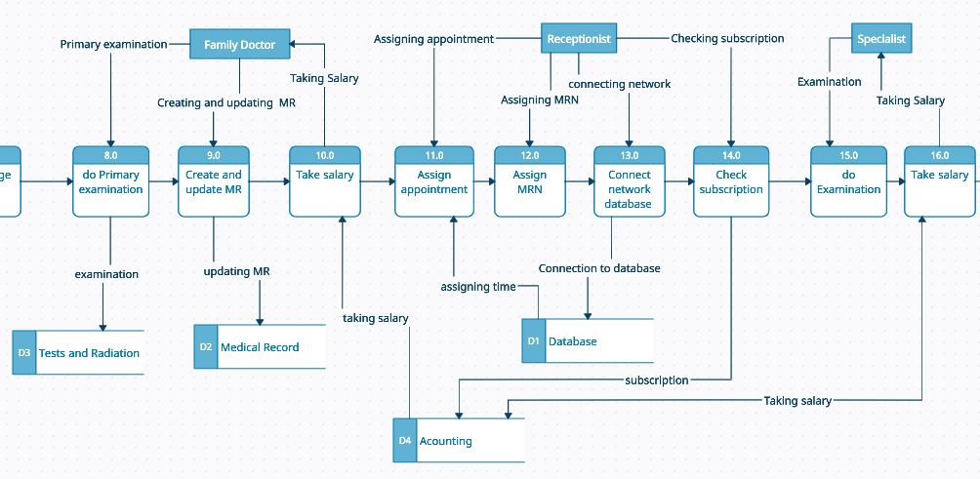

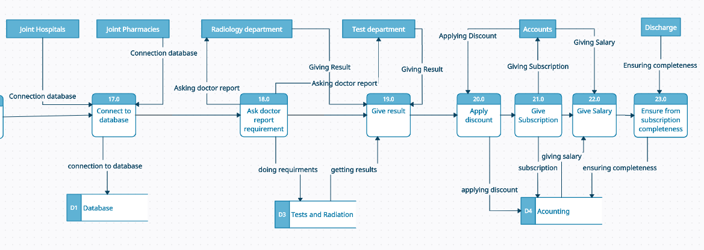

***- Decision Table***

|  |  |  |  |  |  |  |  |  |  |  |  |  |
| --- | --- | --- | --- | --- | --- | --- | --- | --- | --- | --- | --- | --- |
| **Conditions/ Courses of Action** | **Rules** | | | | | | | | | | | |
|  | 1 | 2 | 3 | 4 | 5 | 6 | 7 | 8 | 9 | 10 | 11 | 12 |
| Type of Visit | F | E | F | E | F | E | F | E | F | E | F | E |
| Type of Case | S | S | D | D | S | S | D | D | S | S | D | D |
| Type of Patient | O | O | O | O | C | C | C | C | U | U | U | U |
| Register to System | R |  | R |  | R |  | R |  | R |  | R |  |
| Admission |  | R |  | R |  | R |  | R |  | R |  | R |
| Services | R | R | R | R | R | R | R | R | R | R | R | R |
| Discount on Subscription | R | R | R | R | R | R | R | R |  |  |  |  |
| At Expense of the State |  |  |  |  |  |  |  |  | R | R | R | R |

|  |  |  |  |
| --- | --- | --- | --- |
| **Type of Visit** | **Type of Patient** | **Type of Case** |  |
| **F= First Visit** | **O= Owner** | **S=Stable** |  |
| **E = Else Visit** | **C = Clerk** | **D=Dangerous** |  |
|  | **U = Unable** |  |  |

* 1. ***Data Modeling***

***- ERD***

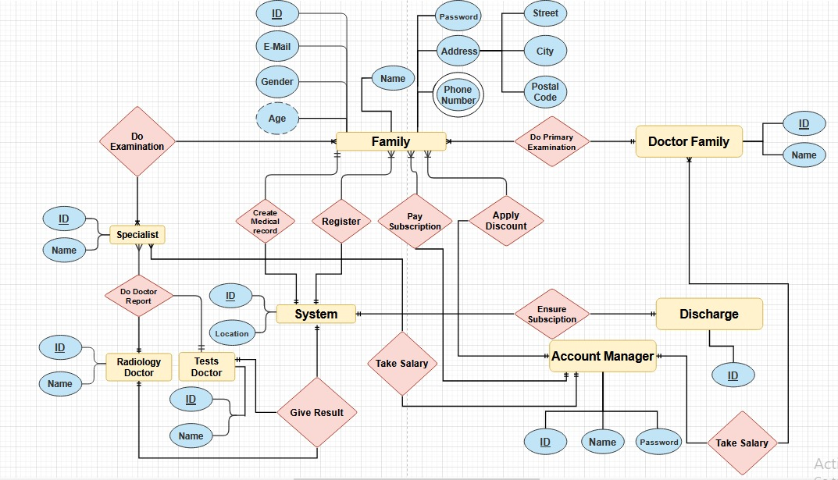

Section 9. Design

* **GUI:**

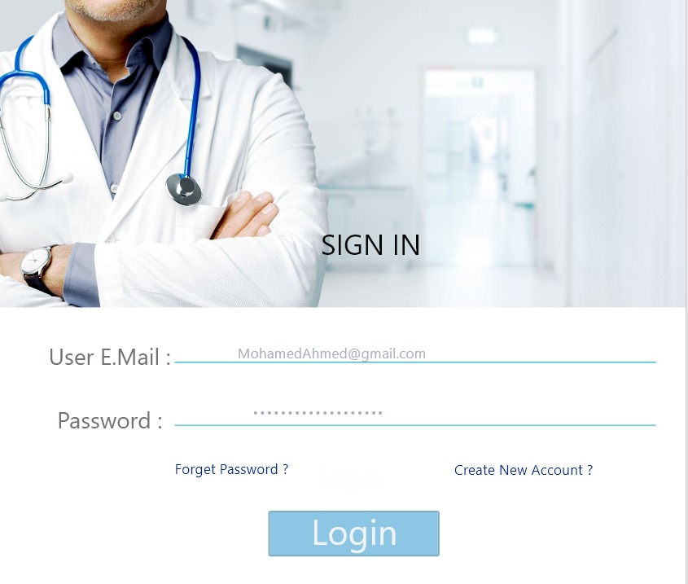

Description:-

* **Registration Form:**

Type: (Form).

Description: It is a form that allows the patient to register into the system by entering the e-mail and the password.

It allows him to enter to the system if this Data is correct or you get new password if he forgot his password.

It allows the patient to create account if he is new comer.

Component: It contains two edit text for registration to system, two links and one button.

One of the edit texts is for email of user and the other is for password of user.

One of the links is for forgotten password if the user can’t remember its password and the other for creating the account if the user enter the system for first time.

The button for login and the user will enter on it if he filled the two edit box.

Entities: (family father and member).

Note: An error message will appear to the user if he doesn’t fill all the edit texts in the form.

* **User Email:**

Type: (Edit Text).

Description: It allows the user to enter his exist email and the email should contain @ --- .com and this email should connect to user ID.

Note: An error message will appear to the user if its email doesn’t contain @ or the user enters incorrect email that doesn’t connect to the database of organization.

* **User Password:**

Type: (Edit Text).

Description: the user should enter his password and it contains user password and it should be at least b8 characters and contain capital case, number and “_”.

Note: An error message will appear to the user if its password doesn’t contain conditions required password.

* **Create New Account:**

Type: (Link).

Description: this link that allows the patient to create new account if he doesn’t have any account to enter to the system.

When the user clicks on this link, it will lead him to the create account page which allows him to enter all information about him to create a new account in the system.

* **Forget Password:**

Type: (Link).

Description: this link that allows the patient to create new password if he forgot his password.

When the user clicks on this link, it will lead him to the create password form which validates from the user ID and create new password.

Note: an error message will appear if the user enter incorrect ID.

* **Login:**

Type: (Button).

Description: this item that allows the patient to enter to the system if the data he has entered is correct.

Note: An error message will appear to the user if he doesn’t fill all the edit texts in the registration form.

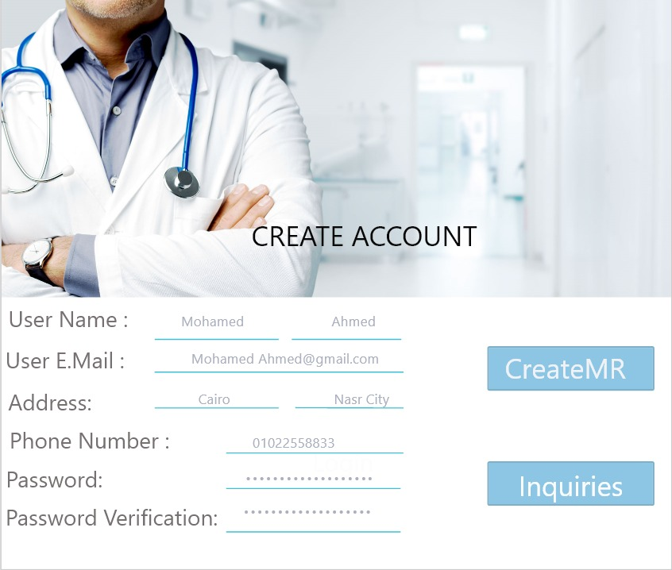

Description:-

* **Create Account:**

Type: (Form).

Description: It is a form that allows the patient to create new account by adding all information about himself and choose the appropriated password.

Component: It contains six edit text for creating new account to system and two button.

First of the edit texts is for user name (father), the second is for phone number, the third is for e-mail, the forth is for password, the fifth is for password verification and the last is for address.

One of the buttons is for creating the medical record and the other for inquires.

Entities: (family father and member)

Note: An error message will appear to the user if he doesn’t fill all the edit texts in the form.

* **User Name (Father):**

Type: (Edit Text).

Description: It should contain the first name and last name of the father of family that will sign up to the universal health insurance.

First letter of names should be capital and an error message will appear to the user if he doesn’t do it.

Note: An error message will appear if he doesn’t do it.

* **Phone Number:**

Type: (Edit Text).

Description: It should be filled with user phone number and it should be 11 number.

Note: An error message will appear if the phone number be less than 11 number.

* **E-mail:**

Type: (Edit Text)

Description: It allows the user to enter his exist email and the email should contain @ --- .com and this email should connect to user ID.

Note: An error message will appear to the user if its email doesn’t contain @ or the user enters incorrect email that doesn’t connect to the database of organization.

* **Password:**

Type: (Edit Text).

Description: the user should enter his password and it contains user password and it should be at least b8 characters and contain capital case, number and “_”.

Note: An error message will appear to the user if its password doesn’t contain conditions required password.

* **Password Verification:**

Type: (Edit Text).

Description: the user fills it with entering a password again to verify it.

Note: An error will appear if the user enters the verifying password incorrectly.

* **Address:**

Type: (Edit Text).

Description: the user should consists of letters and be in details.

Note: An error message will appear if the user doesn’t do it.

* **Create medical record:**

Type: (Button).

Description: this item that will deliver to the form allowing father from create medical record of his family.

* **Inquiries:**

Type: (Button).

Description: this item that will deliver to the form of all information about the system.

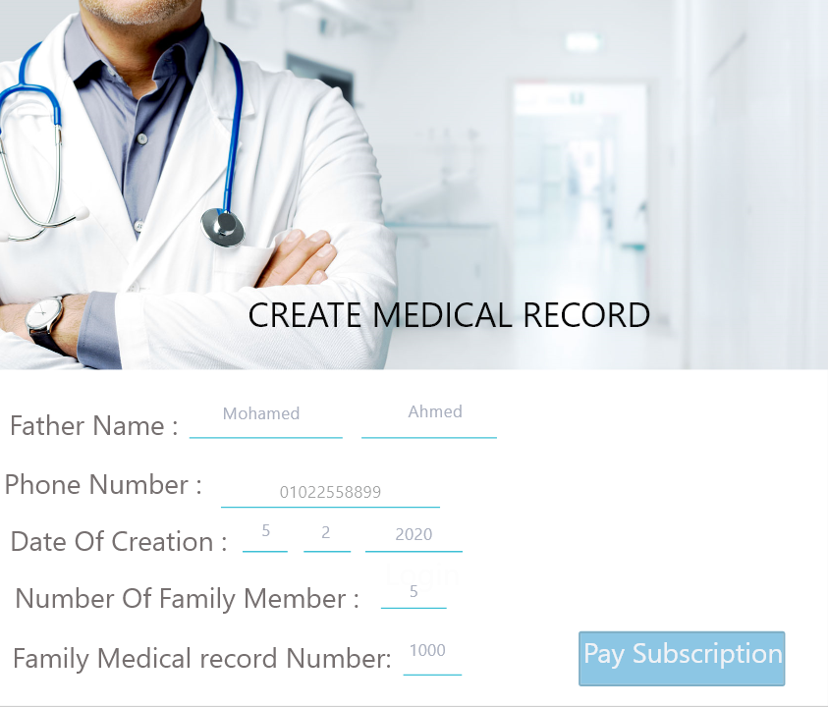

Description:-

* **Create Medical Record:**

Type: (Form).

Description: It is a form that father uses it to sign up family to the system and it consists from several text boxes and a number of buttons, one of them is for paying subscription and the others will be by the number of members of the family and it will determine according to the number of family assigned by the father.

Component: It contains six edit text for creating new account to system and a button.

First of the edit texts is for father full name, the second is for number of the family members, the third is for phone number, the forth is for the family medical record number, the fifth is for date of the creation and the last is for name of the family doctor.

One of the buttons is for paying the subscription.

Entities: (family father and member).

Note: An error message will appear to the user if he doesn’t fill all the text boxes in the form.

* **Father Full Name:**

Type: (Edit Text).

Description: It should contain the first name and last name of the father of family that will sign up to the universal health insurance.

First letter of names should be capital and an error message will appear to the user if he doesn’t do it.

Note: An error message will appear if he doesn’t do it.

* **Number of Family Members:**

Type: (Edit Text).

Description: It should be filled with number of the family members entered by father.

It should be a number.

Note: An error message will appear to the user if he doesn’t do it.

* **Phone Number:**

Type: (Edit Text).

Description: It should be filled with user phone number and it should be 11 number.

Note: An error message will appear if the phone number be less than 11 number.

* **Family Medical Record Number:**

Type: (Edit Text).

Description: It should be filled with number by the organization that assigns it to each family.

* **Date of Creation:**

Type: (Edit Text).

Description: It should be filled with number by the organization in the same date that the father assigns to this form.

* **Name of Doctor:**

Type: (Edit Text).

Description: It should be filled with the name of family doctor that the organization assigned to each family.

* **Pay Subscription:**

Type: (Button).

Description: It is an item that when the user clicks on it, it will driver him to the accounting department to pay the subscription and join in the system.

**Number of Buttons that will driver to medical record of the member that have the same number existed in the button.**

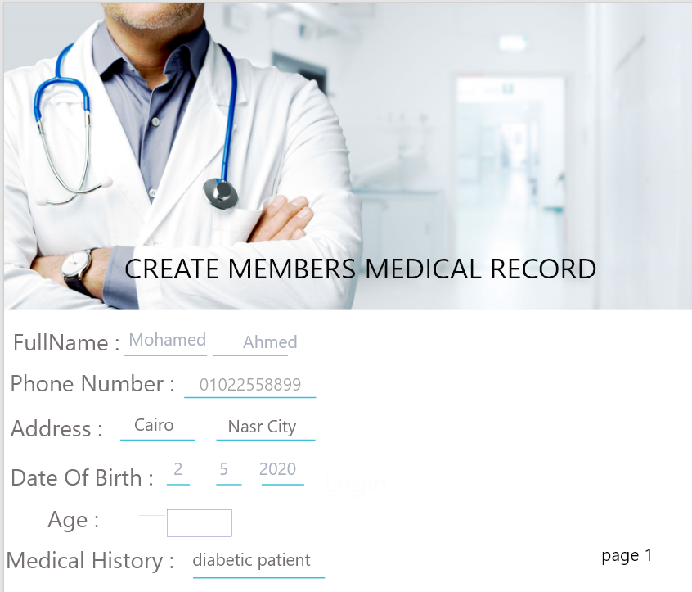

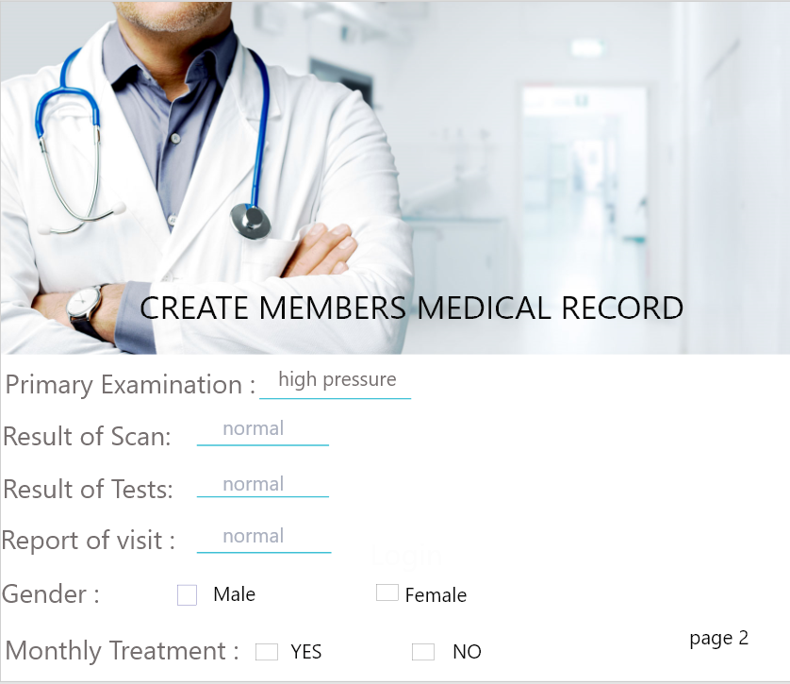

Description:-

* **Medical Record (n):**

Type: (Form).

Description: it is the form of the member that chose its number from create Medical record or the clerk entered its number to the system.

Component: It contains ten edit texts for creating new account to system and three check box.

First of the edit texts is for full name, the second is for phone number, the third is for address, the forth is for the date of birth, the fifth is for age of the patient, the sixth is for medical history, the seventh is for primary examination, the eigthth is for result of the scan, the ninth is for the result of the tests and the last is for the report of each visit.

One of the check boxes is for gender, the second is for the surgery and the last is for monthly treatment.

Entities: (family father, member and adminstrator).

Note: An error message will appear to the user if he doesn’t fill all the text boxes in the form.

* **Full Name:**

Type: (Edit Text).

Description: It should contain the first name and last name of the father of family that will sign up to the universal health insurance.

First letter of names should be capital and an error message will appear to the user if he doesn’t do it.

Note: An error message will appear if he doesn’t do it.

* **Phone Number:**

Type: (Edit Text).

Description: It should be filled with user phone number and it should be 11 number.

Note: An error message will appear if the phone number be less than 11 number.

* **Address:**

Type: (Edit Text).

Description: the user should consists of letters and be in details.

Note: An error message will appear if the user doesn’t do it.

* **Date of Birth:**

Type: (Edit Text).

Description: It is an edit text that should be filled with user birth date and it should be numbers.

Note: An error message will appear if the user enters letters.

* **Age of Patient:**

Type: (Edit Text).

Description: It is an edit text filled with age of each member of family.

It should be a number.

Note: An error message will appear to the user if he doesn’t do it.

* **Medical History:**

Type: (Edit Text).

Description: It is an edit text filled with the diseases of patient that he had and surgeries he done over his life.

* **Primary Examination:**

Type: (Edit Text).

Description: It is an edit text filled by the doctor family that contains patient blood pressure, diabetes and an electrocardiogram.

* **Result of Scans:**

Type: (Edit Text).

Description: It is an edit text filled with the result of scans asked by the family doctor that patient done it in the radiology department.

* **Result of Tests:**

Type: (Edit Text).

Description: It is an edit text filled with the result of tests asked by the family doctor that patient done it in the test department.

* **Report of each Visit:**

Type: (Edit Text).

Description: It is an edit text filled with report of specialist about patient case in each visit he came to hospital and its date.

* **Gender:**

Type: (Check box).

Description: It is a selected item that contains two options male or female and the user should determine his gender.

* **Surgery:**

Type: (Check box).

Description: It is a check box that the patient marks on it when the patient did any surgery.

* **Monthly Treatment:**

Type: (Check box).

Description: It is a check box that the patient marks on it when the patient had any treatment monthly.

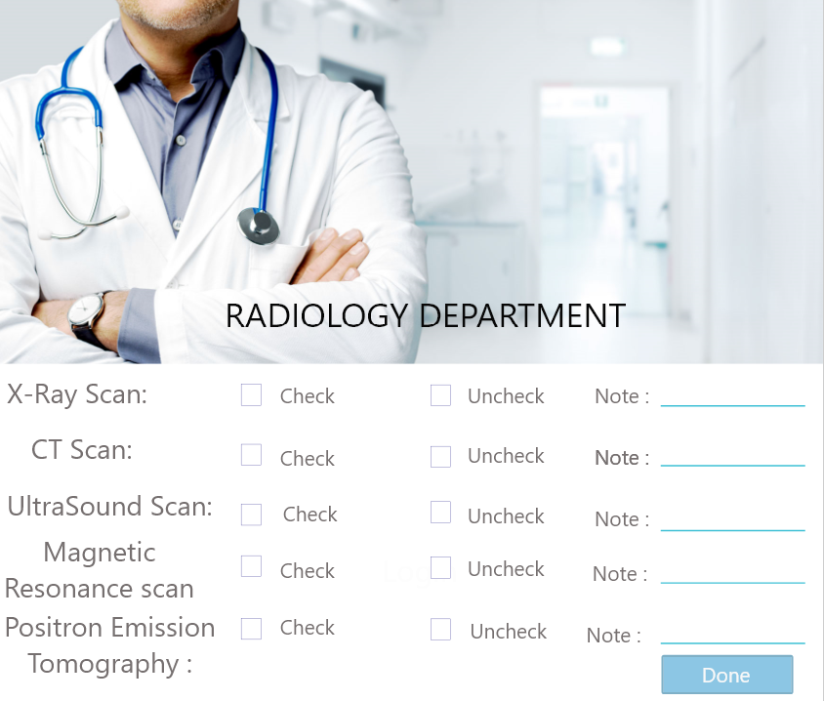

Description:-

* **Radiology Department:**

Type: (Form).

Description: It is the form that consists of all scans types as view text and the patient select if his scan is normal or not and will appear in the bottom note of the scan, he has problem in it.

Component: It contains five text views.

Entities: (family father, member, radiologist and the doctor).

* **X-ray Scan:**

Type: It is a view text.

Description: it has two empty squares one for normal and one for un normal and the patient will mark next of one of these squares according to his case.

* **CT Scan:**

Type: It is a view text.

Description: it has two empty squares one for normal and one for un normal and the patient will mark next of one of these squares according to his case.

* **Ultrasound Scan:**

Type: It is a view text.

Description: it has two empty squares one for normal and one for un normal and the patient will mark next of one of these squares according to his case.

* **Magnetic Resonance Scan:**

Type: It is a view text.

Description: it has two empty squares one for normal and one for un normal and the patient will mark next of one of these squares according to his case.

* **Positron Emission Tomography:**

Type: It is a view text.

Description: it has two empty squares one for normal and one for un normal and the patient will mark next of one of these squares according to his case.

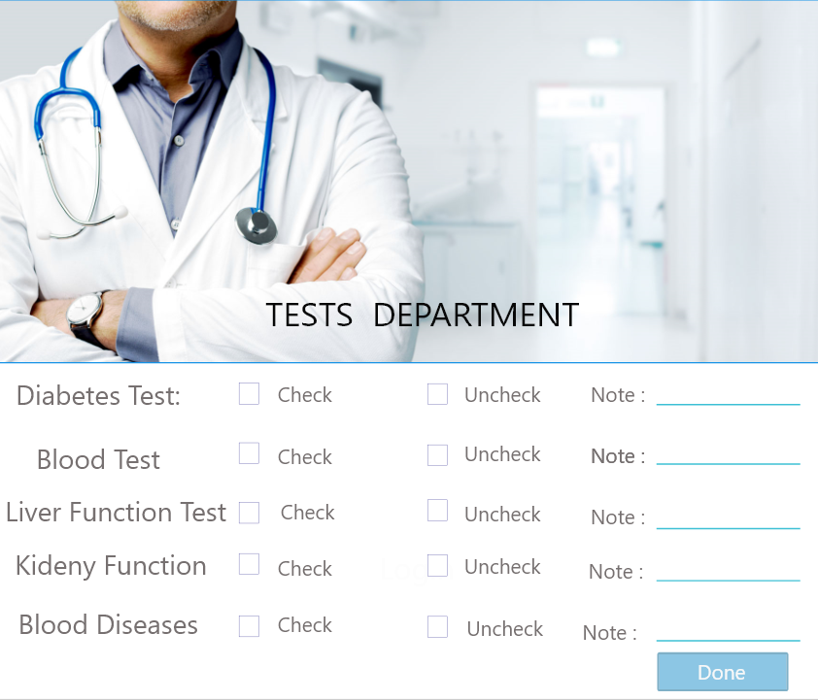

Description:-

* **Test Department:**

Type: (Form).

Description: It is the form that consists of all tests types as view text and the patient select if his test is normal or not and will appear in the bottom note of the test, he has problem in it.

Component: It contains seven text views.

Entities: (family father, member, tester and the doctor).

* **Diabetes Tests:**

Type: It is a view text.

Description: it has two empty squares one for normal and one for un normal and the patient will mark next of one of these squares according to his case.

* **Blood Lipids:**

Type: It is a view text.

Description: it has two empty squares one for normal and one for un normal and the patient will mark next of one of these squares according to his case

* **Liver Function Tests:**

Type: It is a view text.

Description: it has two empty squares one for normal and one for un normal and the patient will mark next of one of these squares according to his case.

* **Tests of Kidney Function:**

Type: It is a view text.

Description: it has two empty squares one for normal and one for un normal and the patient will mark next of one of these squares according to his case.

* **Blood Fluidity Tests:**

Type: It is a view text.

Description: it has two empty squares one for normal and one for un normal and the patient will mark next of one of these squares according to his case.

* **Blood Diseases:**

Type: It is a view text.

Description: it has two empty squares one for normal and one for un normal and the patient will mark next of one of these squares according to his case.

* **Hormones:**

Type: It is a view text.

Description: it has two empty squares one for normal and one for un normal and the patient will mark next of one of these squares according to his case.

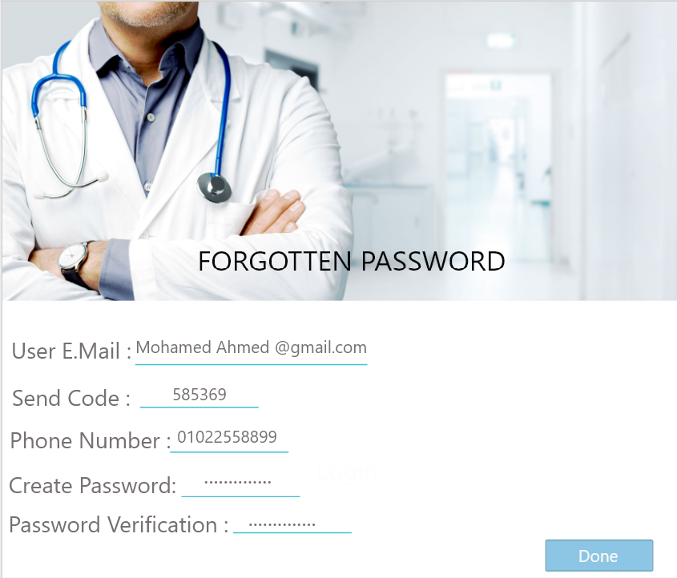

Description:-

* **Forgotten Password:**

Type: (Form).

Description: It is a form to if the patient forgets his password when he logs in the system, he clicks in the link of forgotten password and it will lead him to this form.

Component: It contains five edit texts.

Entities: (member and adminstrator).

* **Email:**

Type: (Edit Text)

Description: It allows the user to enter his exist email and the email should contain @ --- .com and this email should connect to user ID.

Note: An error message will appear to the user if its email doesn’t contain @ or the user enters incorrect email that doesn’t connect to the database of organization.

* **Phone Number:**

Type: (Edit Text).

Description: It should be filled with user phone number and it should be 11 number.

Note: An error message will appear if the phone number be less than 11 number.

* **Code:**

Type: (Edit Text).

Description: It is an edit text that the user should fill it with code that the system sent to his phone number.

* **Create Password:**

Type: (Edit Text).

Description: the user should enter his password and it contains user password and it should be at least b8 characters and contain capital case, number and “_”.

Note: An error message will appear to the user if its password doesn’t contain conditions required password.

* **Password Verification:**

Type: (Edit Text).

Description: the user fills it with entering a password again to verify it.

Note: An error will appear if the user enters the verifying password incorrectly.

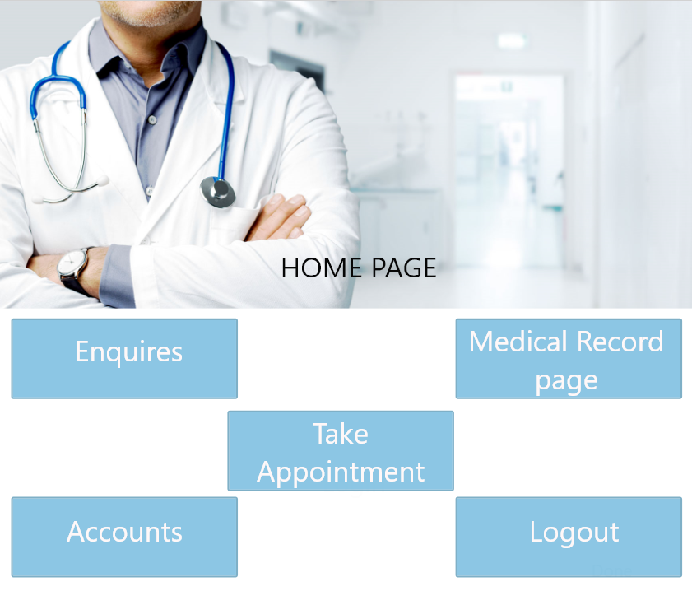

Description:-

* **Home page:**

Type: (Form).

Description: After creation of medical record of new families or login by registered family’s patient go to home page that contain five items.

Component: It contains five buttons.

Entities: (member, adminstrator and the doctor).

* **Enquiry:**

Type: (Button).

Description: this item allow patient to enter to system to know more data about it or to search about anything he want to know about system, this item transfer user to another form that contain search items and system data.

* **Medical record page:**

Type: (Button).

Description: when this item clicked allow patient to go to a form that contain patient medical record (all data about patient that has been entered to it by user or by family doctor and results of radiation and tests).

* **Accounts:**

Type: (Button).

Description: when this item clicked allow patient to go to a form that contain all data about patient accounts (subscriptions, treatment cost, sale rate and surgeries cost) that has been paid or that need to be paid by patient.

* **Take appointment:**

Type: (Button).

Description this button allow patient to take appointment from administrator to check by choosing department, doctor and hospital and assign date and time to check.

* **Logout:**

Type: (Button).

Description this button allow patient to logout after doing examination and required tests and radiations and take medicine and ensure that he has paid his subscriptions and visit has been recorded by family doctor and added to medical record.

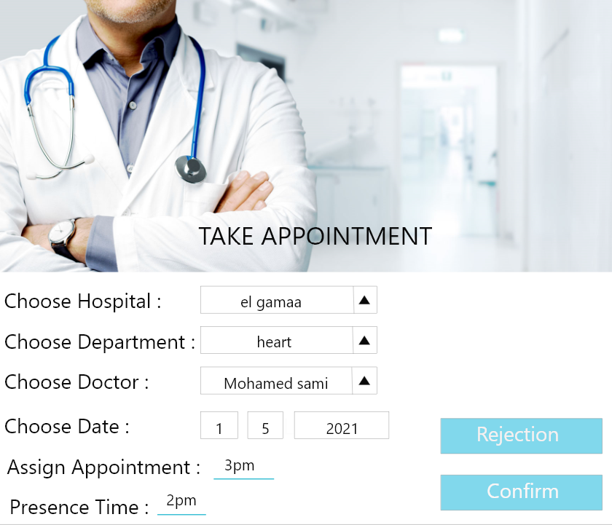

Description:-

* **Take Appointment:**

Type: (Form).

Description: If patient select item of take appointment he will enter to this form which allow him to take appointment to do examination this form contain main items that patient must complete to take appointment.

Components: it consists of four selected items, two text views and two button.

Entities: (member, doctor and adminstrator).

* **Choose hospital:**

Type (select item).

Description: this item allow patient to appropriate hospital that he want to do his examination in this selection based in (nearest hospital to user, best hospital performance, hospital that offer many services to user and hospital that connect with database).

* **Choose department:**

Type (select item).

Description: patient should select wanted department that he wants to do examination in it .it selects depending on (patient case, patient disease and patient complain).

* **Choose Doctor:**

Type (select item).

Description: this item allow user to choose a doctor that exists in selected hospital and selected department from list of doctors that are available this selection based on(best doctor in this branch , best rate doctor by other patient and doctor that is exist in wanted day to examine.

* **Choose Date:**

Type (select item).

Description: this button allow patient to choose date that he want to do his examination in this date written by selected item of (day - month – year ) and according to this date system show available doctor in this day.

* **Assign appointment:**

Type (Text View).

Description: after choosing wanted hospital, wanted department, wanted doctor and appropriate date. System assigns an appointment for each patient this appointment will presented in form of hour that he will do examination in it.

* **Assign time he must be in the hospital:**

Type (Text View).

Description: the system must inform user of time that he must be present in hospital this item reduces waiting time in the hospital and decrease overcrowding and boring from long waiting time.

* **Confirm:**

Type (Button).

Description: after completing the previous data (hospital, department, doctor, date and assign appointment and present time). patient should confirm if this appointment is suitable for him or not.

* **Rejection:**

Type (Button).

Description: after completing the previous data (hospital, department, doctor, date and assign appointment and present time) .assigned appointment may be unsuitable to user and he press this key to reject this appointment.

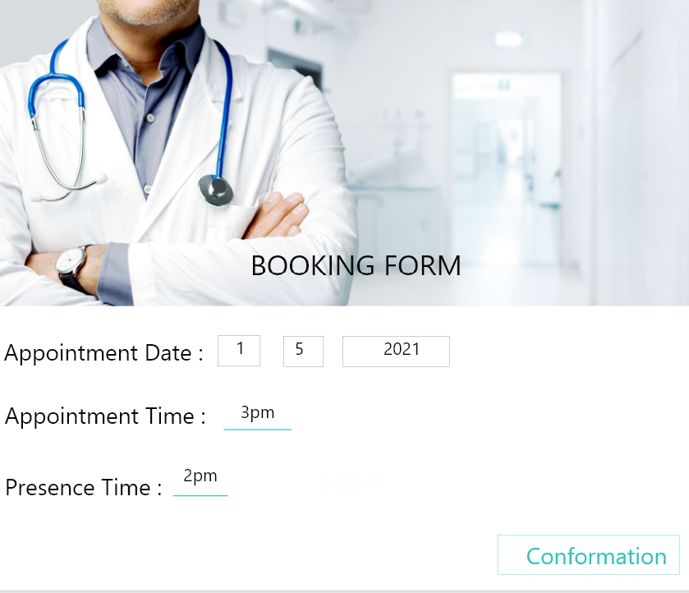

Description:-

* **Booking form:**

Type (Form).

Description: after confirmation of appointment that has been assigned by system this booking is added to system database and user should inform of it this form function is to form patient that his appointment has been recorded this form contain two items.

Components: it consists of two text views.

Entities: (member, adminstrator and doctor).

* **Appointment Date:**

Type: (text view).

Description: this item show date that has been assigned to patient and that has been added to system that the patient should follow.

Note: that this massage is a confirmation message that the patient should follow

* **Appointment Time:**

Type: (text view).

Description: this item show time that has been assigned to patient and that has been added to system that the patient should follow

Note: that this massage is a confirmation message that the patient should follow

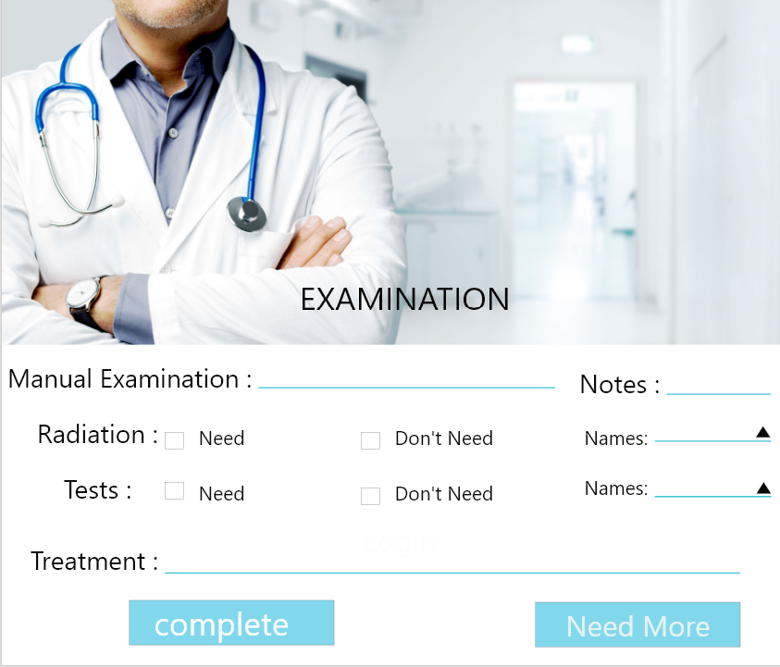

Description:-

* **Examination:**

Type: (Form).

Description: this form includes examination that must be done by specialist. This form includes many processes and data rut should collect about patient and determine by specialist.

Components: it consists of one link, two text views, two check boxes and two buttons .

Entities: (member, adminstrator and doctor).

* **Link of Medical Record:**

Type: (link).

Description: specialist should see medical record of patient during examination to know medical history of patient. (if patient has chronic diseases, patient take monthly treatment, patient has done a surgery and any unmoral data about patient).

* **Result of manual examination:**

Type: (text view).

Description: specialist should do a manual examination in the patient and the result of this examination added to this item to be transferred to medical record with the data about this visit and to determine wanted tests and radiation that patient must do and forgive him appropriate medicine.

* **Note of examination:**

Type: (button).

Description: after examination specialist should be take notes if this is unmoral things and these notes should be added to this item.

* **Radiation:**

Type: (check box).

Description: after examination specialist may need to report some radiations that patient must do in radiation department and see this result to determine case of patient.

* **Tests:**

Type: (check box).

Description: after examination specialist may need to report some tests that patient must do in tests department and see this result to determine case of patient.

* **Treatment:**

Type: (text view).

Description: after examination complement specialist should give patient appropriate medicine this item show all names of treatment that doctor gives to patient .

* **Complete:**

Type: (button).

Description: if examination has been completed and doctor has no longer require anything and treatment has been assign patient click this button to go to pharmacy to take medicine and complete that accounts requirement he discharge and visit recorded to his medical record.

* **Need more examinations:**

Type: (button).

Description: if examination has not been completed and doctor require other things such as (test and radiation) and patient may need a surgery patient click this button to go to this departments to do the requirements and do required surgeries.

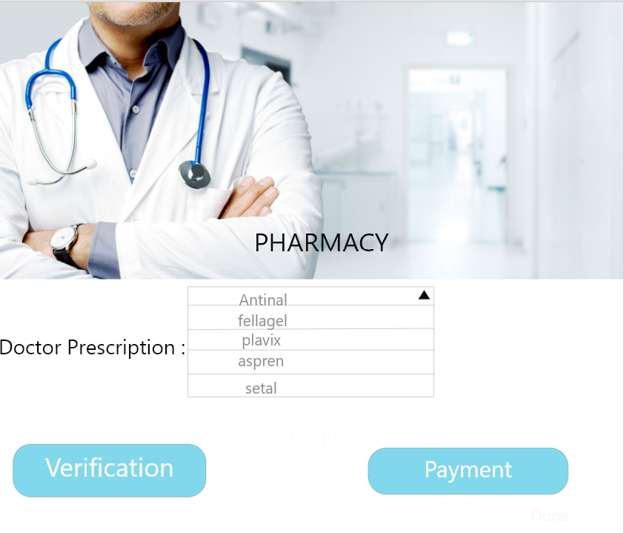

Description:-

* **Pharmacy:**

Type: (form).

Description: doctor gives patient number of treatments. Patient go to pharmacy to takes these medicines and pay these costs in accounts.

Components: it consists of one text views and two buttons.

Entities: (member, pharmacist and doctor).

* **Doctor prescriptions:**

Type: (text view).

Description: pharmacist should give doctor paid treatments. Patient go to pharmacy to takes these medicines.

* **Verification:**

Type: (button).

Description: this button checks if patient has been taken the required treatment that has been written by patient .and all medicines are available.

* **Pay price of medicine:**

Type: (button).

Description: patient should pay the price of the medicines that he has been taken from pharmacy in the accounts.

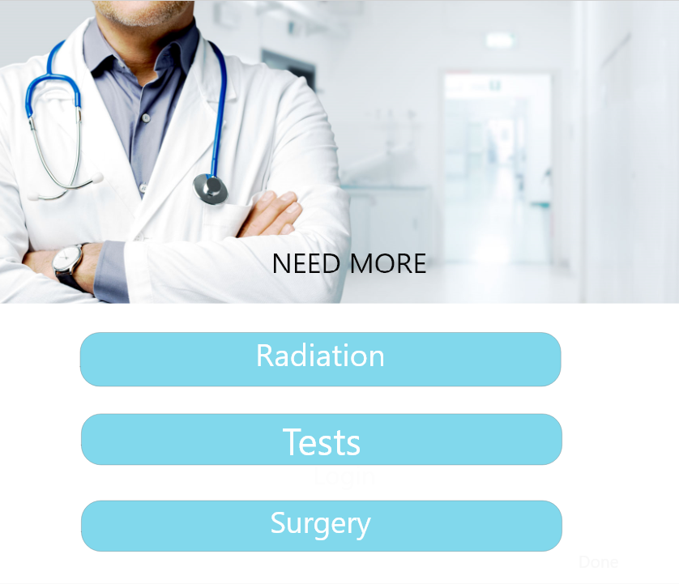

Description:-

* **Need more:**

Type: (Form).

Description: this form contains addition requirement that doctor need patient to do to accurate examination if patient case require this and to do surgery if required.

Components: it consists of three button.

Entities: (member, radiologist, tester and doctor).

* **Radiations:**

Type: (Button).

Description: this item contains addition radiations requirement that doctor need patient to do to accurate examination if patient case require this and to do surgery if required.

* **Tests:**

Type: (Button).

Description: this item contains addition tests requirement that doctor need patient to do to accurate examination if patient case require this and to do surgery if required.

* **Surgery:**

Type: (Button).

Description: this item contains if doctor that patient case requires to do a surgery this item will lead patient to surgery form.

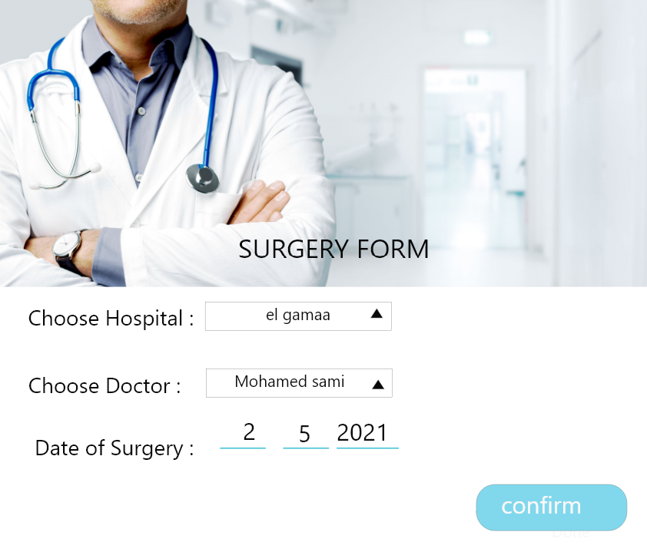

Description:-

* **Surgery Form:**

Type: (Form).

Description: this form contains surgery that patient should do and patient allowed to choose hospital and know date that he will do in it.

Components: it consists of two edit texts, one text view and button.

Entities: (member and doctor).

* **Choose hospital:**

Type: (edit text).

Description: this item allow patient to appropriate hospital that he want to do his surgery in this selection based in (nearest hospital to user, best hospital performance, hospital that offer many services to user and hospital that connect with database)

* **Date of surgery:**

Type: (edit text).

Description: this button allow patient to choose date that he wants to do his surgery in this date written by selected item of (day/month/year) and according to this date system show time of it.

* **Doctor:**

Type: (text view).

Description: this item shows the doctor that will do this surgery, the system add doctor name to database of doctor.

* **Confirm:**

Type: (button).

Description: if patient accepts all the item in the surgery form, he click this button to go to accounts to pay the cost of surgery.

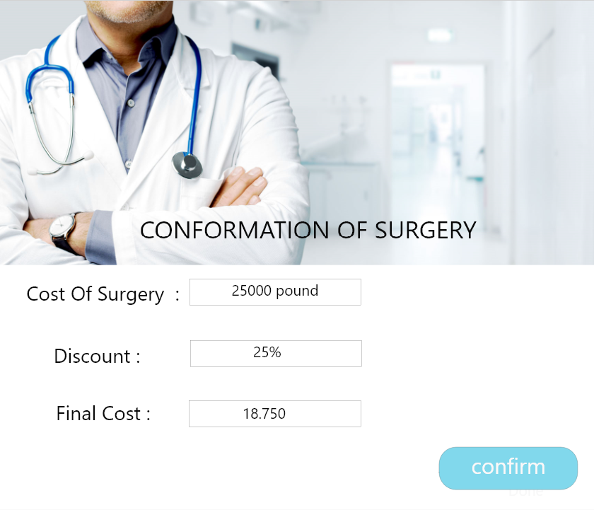

Description:-

* **Confirmation of surgery:**

Type: (Form).

Description: in this form patient complete items that are related to surgery.

After patient accepts all the item in the surgery form, he click this button to go to accounts to pay the cost of surgery.

* **Pay price of surgery:**

Type (text view)

Description patient should pay the price of the surgery that he has been done in the accounts to complete this process in medical record and database.

* **Discount:**

Type (text view)

Description patient should take a discount according to his category in the price of the surgery that he has been done.

* **Confirm:**

Type (button)

Description if patient accepts all the item in the surgery and complete all financial data. He clicks this button to go to accounts to pay the cost of surgery.

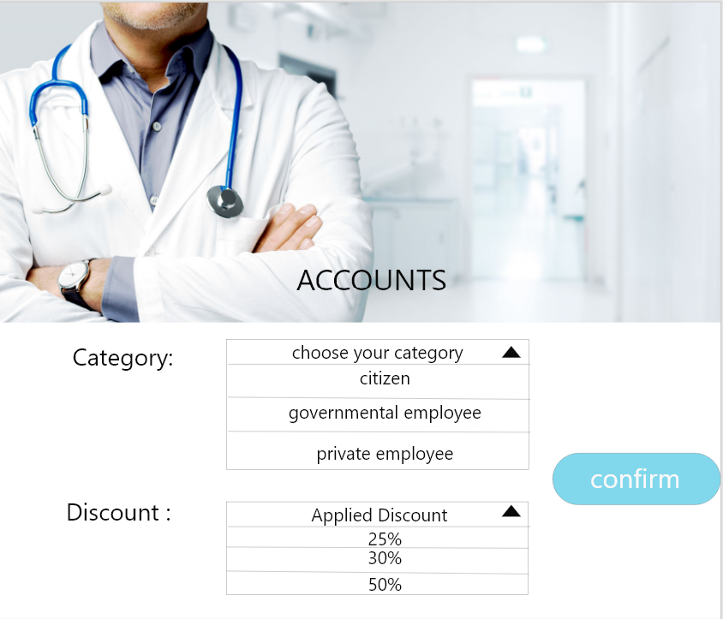

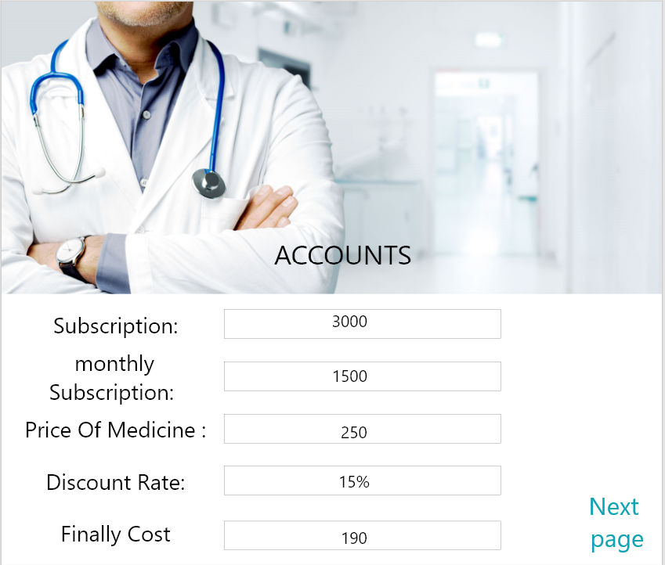

Description:-

* **Accounts:**

Type: (Form).

Description: patient examination, take medicine radiation, tests, surgery and subscription should be paid in this department and add the result of this paid to patient medical record.

Components: it consists of one edit text, 13 text view and two buttons.

Entities: (member and accountant).

* **Category:**

Type: (edit text).

Description: include the branch in the country that patient belongs to it to apply the discount according to this branch.

* **Confirm:**

Type: (button).

Description: after entering patient branch to set applied discount he should click in this button to confirm this data.

* **Discount:**

Type: (text view).

Description: apply the discount according to his branch in the country that patient belongs to it.

* **Confirm:**

Type: (button).

Description: after taking discount according to his branch in the country. He should click in this button to confirm this data.

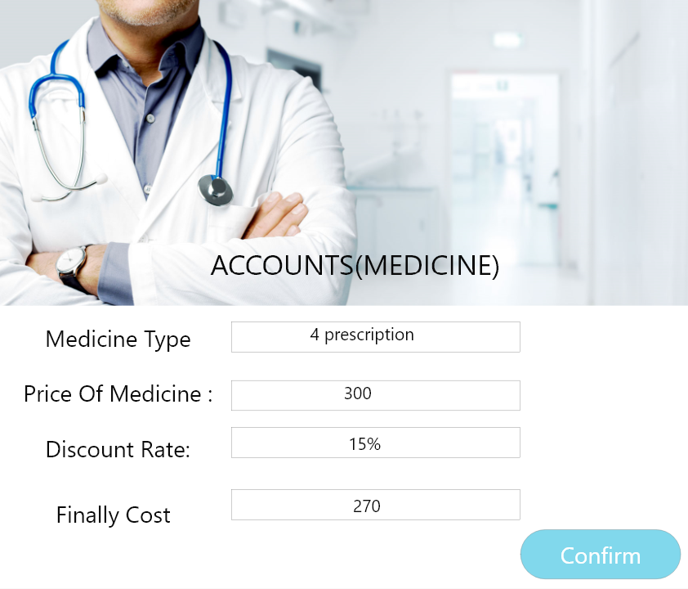

Description:-

* **Medicine type:**

Type: (text view).

Description: after examination doctor give patient a set of medicines and he take them from pharmacy and this medicine transfer automatically to account for paying.

* **Price of medicine:**

Type: (text view).

Description: the price of the medicines that he has been taken from pharmacy are added to this item.

* **Discount:**

Type: (text view).

Description: apply the discount according to his branch in the country that patient belongs to it.

* **Applying Discount:**

Type: (text view).

Description: apply the discount according to his branch in the country that patient belongs to it in the cost of the medicine that he has taken from pharmacy.

* **Finally cost:**

Type: (text view).

Description: after applying the discount according to his branch in the country that patient belongs to it in the cost of the medicine that he has taken from pharmacy the final result will appear here.

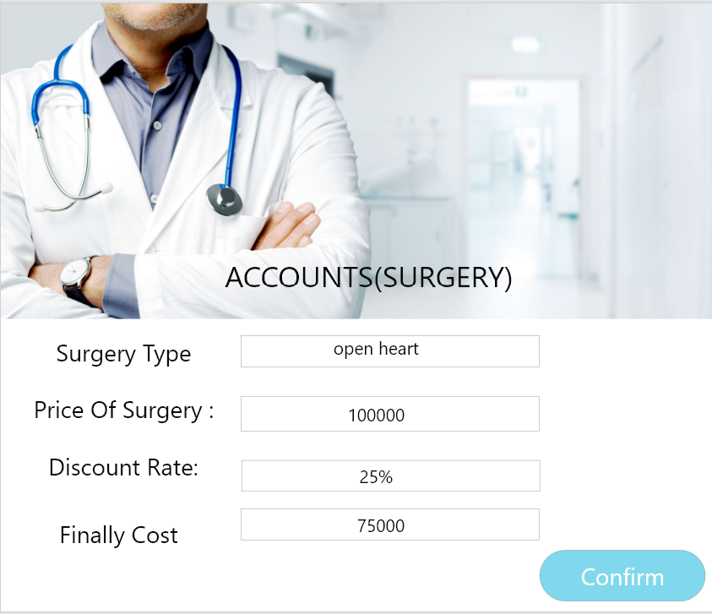

Description:-

* **Surgery type:**

Type: (text view).

Description: according to surgery type that is written in the surgery form is transferring automatically to account for paying.

* **Price of surgery:**

Type: (text view).

Description: the price of the surgery that he has been done by the doctor is added to this item.

* **Discount:**

Type: (text view).

Description: apply the discount according to his branch in the country that patient belongs to it.

* **Applying Discount:**

Type: (text view).

Description: apply the discount according to his branch in the country that patient belongs to it in the cost of the surgery that he does.

* **Finally cost:**

Type: (text view).

Description: after applying the discount according to his branch in the country that patient belongs to it in the cost of the surgery that he has does. The final result will appear here.

* **Confirm:**

Type: (button).

Description: after paying costs. he should click in this button to confirm this data.

Section 10. Implementation and Operation

***10.1 Implementation (Coding):***

Once the system design phase is over, the next phase is coding. In this phase, developers start build the entire system by writing code using the chosen programming language. In the coding phase, tasks are divided into units or modules and assigned to the various developers. It is the longest phase of the Software Development Life Cycle process.

***10.2 Implementation (Testing):***

Once the software is complete, and it is deployed in the testing environment. The testing team starts testing the functionality of the entire system. This is done to verify that the entire application works according to the customer requirement. During this phase, QA and testing team may find some bugs/defects which they communicate to developers. The development team fixes the bug and send back to QA for a re-test. This process continues until the software is bug-free, stable, and working according to the business needs of that system.

***10.3 Operation:***

* System changed to reflect changing conditions
* System obsolescence

Section 11. Feature work

Universal Health Insurance is a new idea but not the last version of this topic, It's useful because it makes all people from different levels are equal. Maybe In the future this system become International System not only National as it's now applied. Helps in making the whole world as a small village.

**Conclusion**

There is little question that universal health care coverage is appealing from multiple points of view. In particular, uninsured families, insured families, taxpayers, emergency physicians, and consultants would all benefit directly from an effective universal health care coverage program. Even countries that have universal health care coverage are not free of problems, including influence by politicians and sensationalized media coverage .If we can develop a proper implementation strategy, there is no reason to avoid the development of universal health care coverage